# Server Side RAD

## Lab 1 Setup

### Part 1 Install Maven Plugin in Eclipse

* Open Eclipse Neon.1.
* Click on *Help/Eclipse Marketplace*.
* When the Marketplace opens type *Maven Integration for Eclipse* into the search box and press *Go*.
* Select the *Maven Integration for Eclipse (Luna and newer) 1.5* and press *Install*.

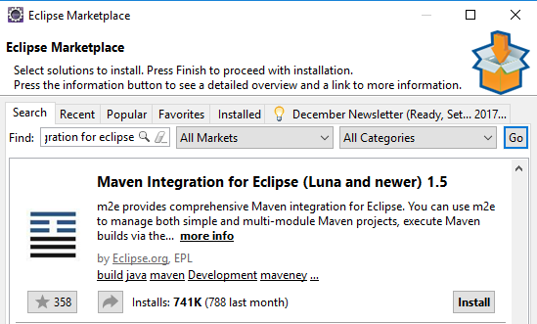

### Part 2 Install Spring IDE Plugin in Eclipse

* Open Eclipse Neon.1.
* Click on *Help/Eclipse Marketplace*.
* When the Marketplace opens type *Spring IDE* into the search box and press *Go*.
* Select the *Spring IDE 3.8.3.RELEASE* and press *Install*

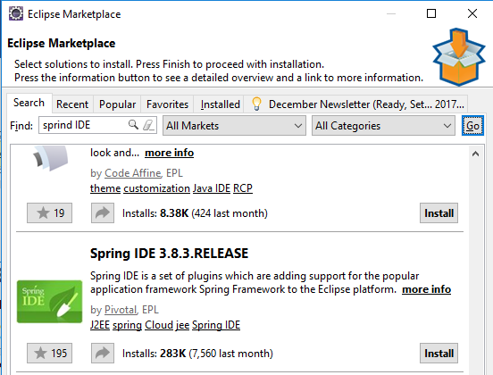

* When a dialog box appears, press *Confirm*.
* On the next screen, accept the license agreement and press *Finish*.

### Part 3 Check everything is installed OK

* Create a new Maven project in Eclipse by selecting *File/New/Other/Maven/Maven Project* and press *Next*.
* Select *Create a simple project (skip archetype selection)* and press *Next*.

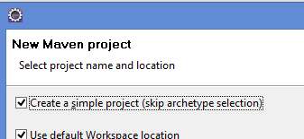

* Enter a Group Id e.g. *com.lab1*.
* Enter an Artifact Id e.g. *lab1-test*.
* Press *Finish*.
* Create a new class called *App* in the *com.lab1* package.
* Create another class called *Person* in the same package as follows:

package com.lab1;

public class Person {

public void sayHello() {

System.out.println("Hello from Person");

}

}

* Update the *App* class as follows:

package com.lab1;

public class App {

public static void main(String[] args) {

Person person = new Person();

person.sayHello();

}

}

* Run the program as Java Application and make sure *“Hello from Person”* is printed.